|  |
| --- |
|  |
| **Online Canteen Ordering System** |
| Submitted By: Prajwal Rawat |
|  |
| **Rawatrocking117@gmail.com** |
| **[Pick the date]** |

**Catering Industry**

**Stakeholders**

**Task 1. Identifying stakeholders – Create a list of stakeholders (as taught in Business Analysis Planning and Monitoring Knowledge Area)**

|  |  |  |
| --- | --- | --- |
| **S.no** | **ACTOR** | **What they can do on the software created** |
| 1. | Employee/Customer/End user | * Employee or New jonnie able to create an account * Employee able to see the available items in canteen menu * Employee able to select from the food menu and place order before 11.30 * Employee should be able to add or delete item before placing order * Employee should be able to see the order preparation time * Employee should be able to rate the food and give review on food * Employee should be able chose to take away or deliver food on table * Employee should be able to see the total payment to be deducted for the food |
| 2. | Canteen Manager | * Canteen manger should be able to create food menu; the food items should be updated with price * Canteen manager should be able to update menu on daily basis * Canteen manager should be able to cross out the sold out item on the food menu * Canteen manager should be able to list food items according to the availability * Canteen manger should able to request food delivery at employee station |
| 3. | Order Process | * Canteen manager should be able to see all the order * Canteen manager should be able to separate ongoing order and complete order * Canteen manager should be able to sort order by priority and time consumption * Canteen manager should be able to request delivery of food at employee workstation |
| 4. | Meal/Food Delivery Boy | * Meal Delivery Boy should be able to see food delivery request notification * Meal Delivery Boy should be able to accept food delivery as per request * Meal Delivery Boy should be able to deliver food as per request * Meal Delivery Boy should be able to able to update order of delivered food items status * Meal Delivery Boy should be able to able look into costumer info as per delivery address and employee information * Meal Delivery Boy should be able to update delivered food status and cross out as order done |
| 5. | Payroll system | * The payroll team needs to be able to view the total monthly order payments deducted from the payroll. End of month before salary payment * The payments team should be able to see a list of orders along with the price per employee. * The payment team should be able to maintain employee payment record |
| 6. | Management | * Management should be able to receive reports (by daily,weekly,monthly)   + Most order food items   + Total number of employee login   + Feedback on food and delivery   + Total monthly earning from the system   + Able to register traffic during peak hour of food ordering |
| 7. | Implementation SME | * Design the site as per requirement * Server should be able to handle 1500+ employee * System capability * Secure the login information for future use on site |
| 8. | Operation Support | * Able to Handle operational support tasks and keep 1500 employees up and running with applications available during working hours |
| 9. | Project manger | * Managing the production of the required deliverables * Plan and monitor the project * Project Manger is responsible for the successful implementation of an online canteen ordering system project |
| 10. | Tester | * Perform function of application and capability of application * Check the necessary requirement before the application release |
| 11. | Chefs | * Receive food order and mark as complete task as done |
| 12. | Sponsor | * Authorizes and release the requied amount of budget for the initiative |

**Task**

**2. Identify the problem statement in this system.**

**Problem Definition and Solution**

* Here you can mention why we need this canteen system for both: the canteen and the customer. Can write more than 1 point.

Problem statement:

* Management calculates that it took about 60 minutes for the staff to leave lunch and return. It took almost 30-35 minutes waiting in line to collect food and sit at a table to eat.
* It only takes 10-15 minutes to eat. The rest of his ten minutes were spent using the elevator to and from the dining room.
* Employees do not always have a choice of meals as the cafeteria runs out of certain items. Canteens waste a significant amount of food by discarding what is not purchased.

Change Need:

To shorten queues or wait for an empty table, introduced a token system according to the floor or order food online through our website to reduce waiting time and food waste.

Possible solution:

1. Increase Number of table in canteen
2. Advance Token base food booking
3. Advance seat booking for table
4. Online delivery at work station
5. Worst case- Employee bring own lunch and canteen faculty is shut down

**3. Identify objectives of the new Canteen Ordering System.**

* Advantage of Canteen Ordering System:
* Advance Booking will save time for service employee
* Easily availability of food item for employee
* Reduce food wastage
* Reduce queue time for food ordering
* Availability of food items

Objectives:

**Business Objective 1:**

Reduce canteen food wastage by a minimum of 30% within 6 months following first release.

Scale: Value of food thrown away each month by examining the canteen inventory

* Previous - 25% wasted
* Must plan for: Less than 15%

**Business Objective 2**:

Reduce canteen operating costs by 15% within 12 months, following initial release.

**Business Objective 3:**

Increase average effective work time by 30 minutes per employee per day, within 3 months.

**Business Objective 4:**

By making the ordering process automated and by delivering the food to the user's workstation, the canteen will be able to operate with lesser manpower.

**4. Create as-is and future process map (using flowcharts). You can use any of the popular tools in the market like Microsoft Visio, Lucid Chart, Creately, Pidoco, or Balsamiq**

**Existing System**

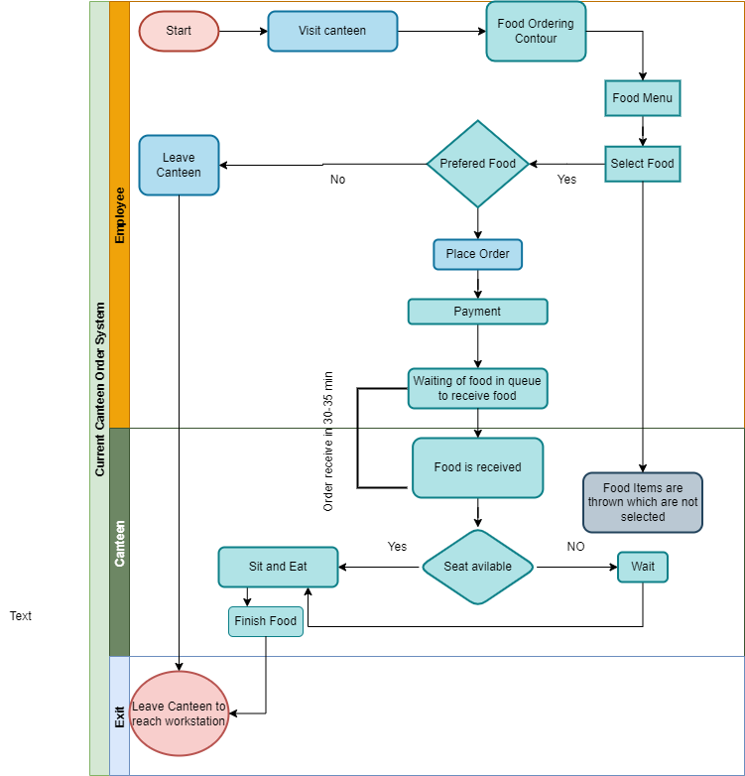

**Future Process**

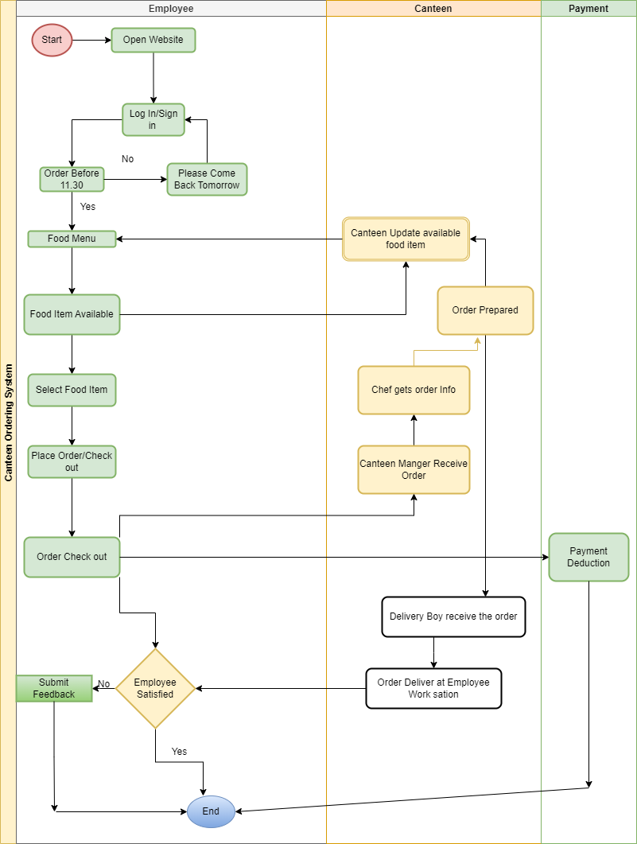

**5. As a Business Analyst working on this project, find out the scope of the Canteen Ordering System. To find the scope you can use the case diagram (UML) or context diagram for the same.**

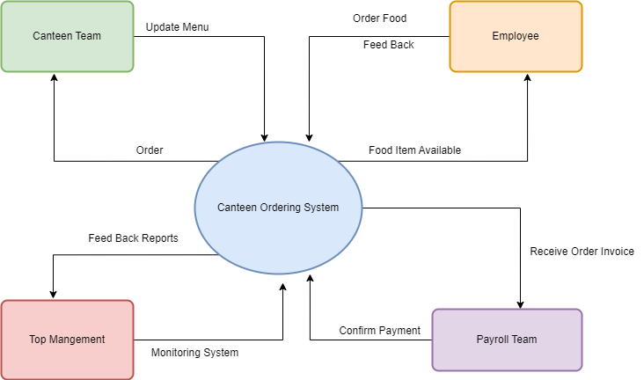

**6. Write down the main features that need to be developed.**

* A database for the app with employee ID’s and menu items’ ID’s
* Creation of log in credentials
* Availability of Food items
* Ability to select meal and edit meal before checkout
* Chef should be able to add and remove food items depending on availability
* User should not able to edit or cancelled orders after checkout
* Handshake with payroll system for salary deduction
* Ability to produce various reports as may be required
* Canteen manager to be able to view and assign menu to chef for preparation
* Canteen manager should be able to assign prepared meal to delivery boy for delivery
* Higher Management should be able to monitor review data and employee feedback

**7. Write the in-scope and out-of-scope items for this software.**

**In Scope**

* Employee Sign up/sign in
* Menu Page
* Ordering Page
* Online payment
* Food usage and left
* Support 1500 employee data
* Customer Feedback
* Payment deduction by payroll system

**Out Scope**

* Payment in Cash
* Cash refund
* Cannot order food after 11.30
* Multiple location cannot be added

**8. Draw an activity diagram for the system.**

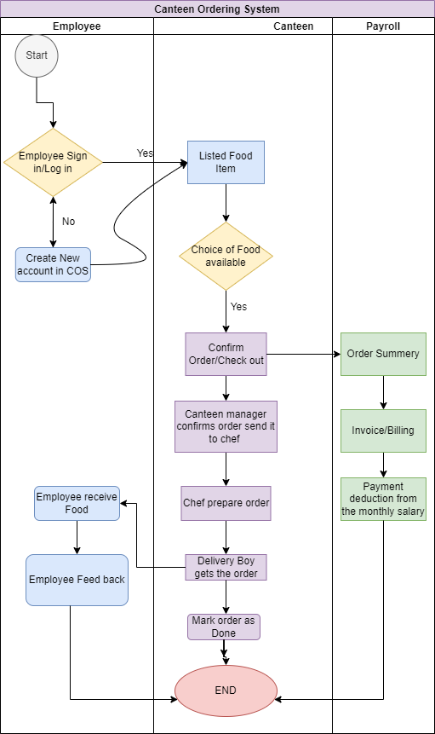

**9. Draw an ER diagram of the system.**

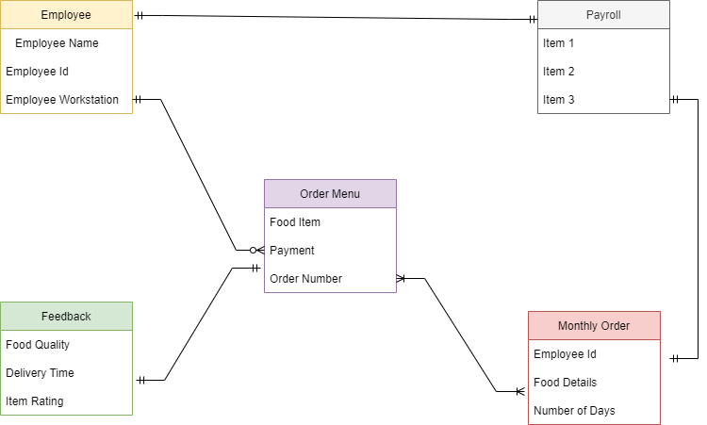

**10. Write out the business requirements,**

**Functional requirements**

* Web portal for food ordering
* New user registration
* Existing user log in
* Update menu for day
* Order place before 11.30am
* Ability to submit feedback by employee
* Ability to add/ remove food item
* Ability to select delivery location
* Once check out, order cannot be cancelled or edited
* Ability to log out from account

**Non-functional requirements.**

* Server able to hold data of 1500+ employees
* Availability: After 11.30am the system shall not allow user to place order for lunch time
* Usability: The web page should be able to work smoothly, it should be self expanding and user friendly.
* Environment: The program website should be easy to use as any new user should be able to order without facing any difficulty.

**11. Draw wireframes or mock screens for any two of the features namely Menu Creation and any other feature as deemed fit by the student. (Use the technique prototyping or wire framing that is taught in the Training). You can use any of the wireframing tools like Microsoft PowerPoint, Microsoft Word, Balsamiq, Sketch, Adobe XD, Adobe Illustrator, Figma, UXPin, InVision Studio, InVision Freehand, or Moqups.**

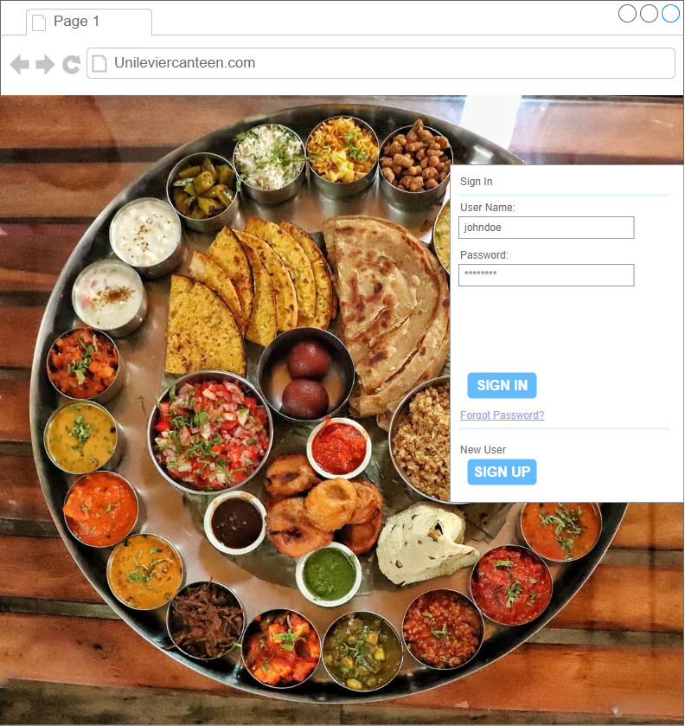

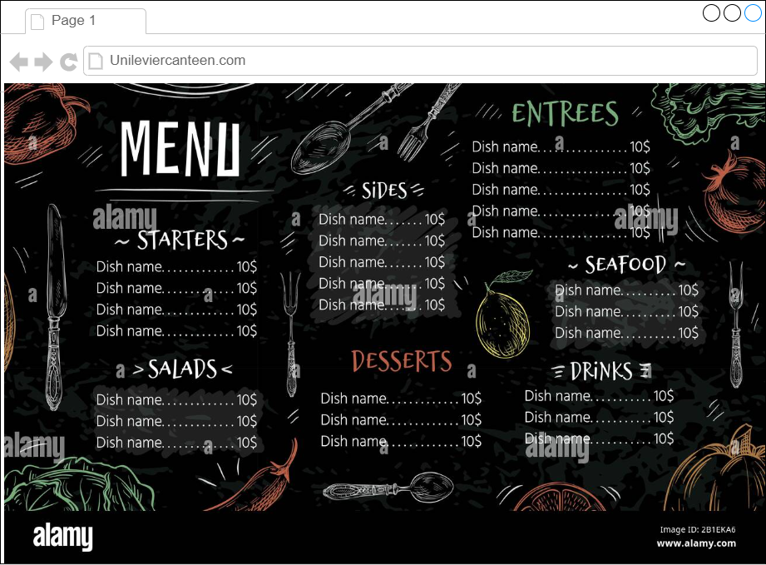

**Advantages and Objectives**

Advantages of the Canteen Ordering System:

* Write down the advantages for canteen and the employees.

**Objectives:**

* Mention in points what will be objective of the system.

**Existing System**

* How is the existing system? Does it have any of the mentioned features already?

**Proposed System**

What is the proposed solution or system? Mention in points how the system itself will be for the user.

* User friendly interface
* …
* …

**Scope using *use case diagram* (UML)**

Create a use case diagram including all the actors and processes for an end to end process of the system.

**Scope using *context diagram***

Depict the scope using Context diagram.

**In Scope**

* Mention the name of features and what they are used for.

**Outof Scope**

* What are the facilities or features—for both patron and the canteen—the are out of scope or cannot be implemented now.

**Activity Diagramfor theSystem:**

Create an activity diagram for the system.

**ER Diagram for the System:**

Create an ER Diagram for the system you have designed.

**Preconditions and Triggers: Example**

* What user/manager should be able to do in a step?
* What are the triggers?
* What is the basic flow?
* What are the data elements?
* In case of errors, what happens?

**Business Requirements:**

**Business objective – 1:**

**Business objective – 2:**

**Business objective - 3:**

**Business objective - 4:**

**Functional Requirements**

* Write down all the functional requirements for the system.

**Nonfunctional Requirements**

* Write all the nonfunctional requirements for the system.

**System Requirement:**

**Usability:**

**Environments**